MACH4METAL

metalworking machinery
Transito 21
6909 DA BABBERICH Netherlands
Tel. +31 (0)316-247123
Fax: +31 (0)316-247956
info@mach4metal.com
www.mach4metal.com

Bank No : 66.52.13.883
IBAN : NL33 INGB 0665 2138 83
BIC : INGBNL2A

EUROMAC CX 750x30CNC
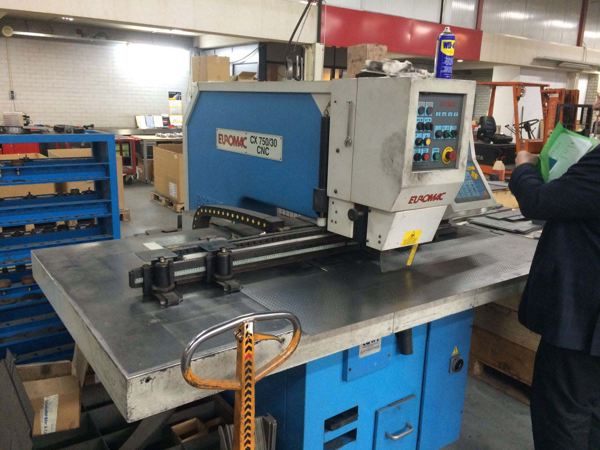
- Make : EUROMAC Italia
- Typ : CX 750 / 30 CNC
- Mach. No : 20123
- Age : 1995

- Table length : 2.480
- Table width : 1.300

- Working length : 1.250
- Working width : 750
- Max. sheet thick : 6 mm
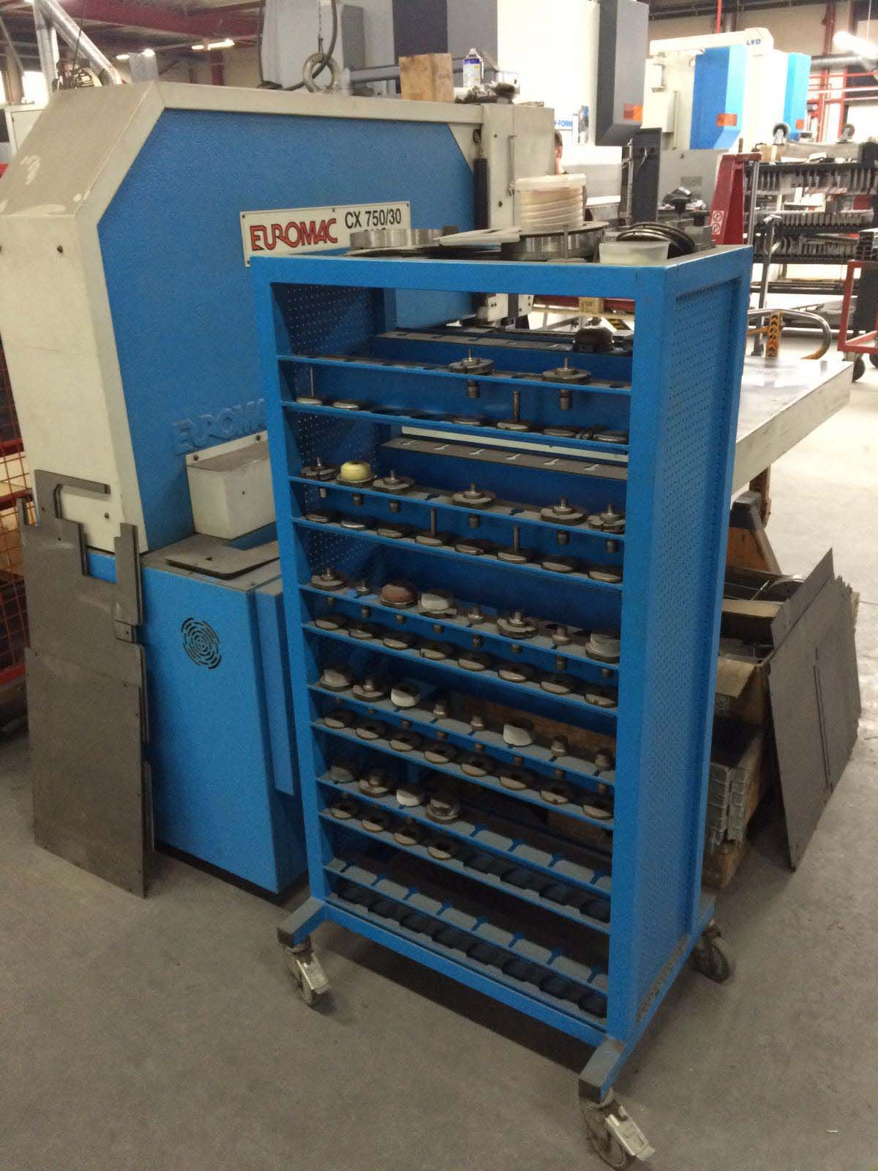

- Power : 4 kW
- Change speed : 1 0 – 15 Sec
- Position accuracy : 0,1 mm
- Feeds all directions : 30.000 mm/M

- Dimensions
- Length : 2.480
- Width : 2.030
- Height : 1.900
- Weight : 3.200

- Large tooling package ca 50 pieces
- Under power
- Bought from 1e owner
- Sheet clamps

Please Note: The above information has been obtained to the best of our ability and belief from, and from the manufacturers where possible. It is given in good faith, but its accuracy can not be guaranteed. Accordingly, it will not form a representation or constitute contractual terms. We advise you to check any vital details!

